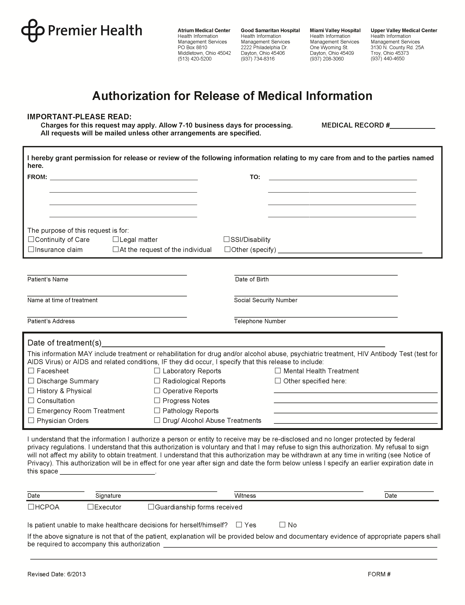
University of Michigan Hospital and Health Center
Release of Information Unit
2901 Hubbard Street Room 2722
Ann Arbor, MI 48109-0000
Axiom Requisition Copy Service
2869 Jolly Road
Okemos, MI 48864
Ph: (877) 886-5090 Fax: (517) 886-4116
x
Batman

Secret Location, Gotham, NJ
01/01/1979
xxx-xx-5555

End of Litigation
FROM 01/01/1979 TO PRESENT: Any and all MEDICAL RECORDS, including but not limited to patient history form(s), reports, etc. pertaining to Batman SSN: xxx-xx-5555, DOB: 01/01/1979.

